

# Web Technologies 1

**HTML PROJECT**

***INSTRUCTOR: Rubem Linn***

***CLASS: Summer 2018 (CSD 1113 _9 )***

|  |  |
| --- | --- |
| **Submitted by:** | **kirandeep kaur – C0740003**  **Nisha Nisha – C0736098**  **Xiao wu – C0727686**  **palwinder kaur- C0737690** |

|  |  |
| --- | --- |
|  | **DATE :2018-08-07** |

**SECTION 1**

**-What is the Purpose of the Website?**

To provide travel itinerary, including guides, tickets, hotels, transportation and gain new clients.

The Forward Active Tour and Travels mission: you will encounter friendly, competent travel professionals who will provide you with current and convenient schedules in addition to the lowest available fares.

**- Who is the Target Audience?**

Active Tour and Travels customers are adults between the ages of 18 and 50 from all over the world. It basically targets:

* private travel
* honeymoon trips
* family trips
* group trips

**- How many pages will be included in your website?**

The initial website will consist of five webpages arranged in a hierarchal structure with links to the home page on every page. Each webpage will include a header area, navigation area, main content area, and footer area.

The pages are as follows:

1. Home：Display pictures and videos of famous attractions to attract customers' attention, and the right quick registration is convenient for customers to click.
2. About Us: Information about tour and travel company
3. Contact：Provides phone number, email address, physical address an map with location of office address
4. Registration：A contact form in this allows the user to directly contact to the company.
5. Tours and Vacation：Display a list of travel destination options for customers to make travel plans

**- What graphics will you use on the website?**

A logo is developed by one of our team members. This is a tour and travel site containing text, images, and videos. Most of picture used are royalty free.

**- What colors will you use on the website**

We want to use sky blue and dark blue which symbolizes the natural color. That makes the customers feel comfortable.

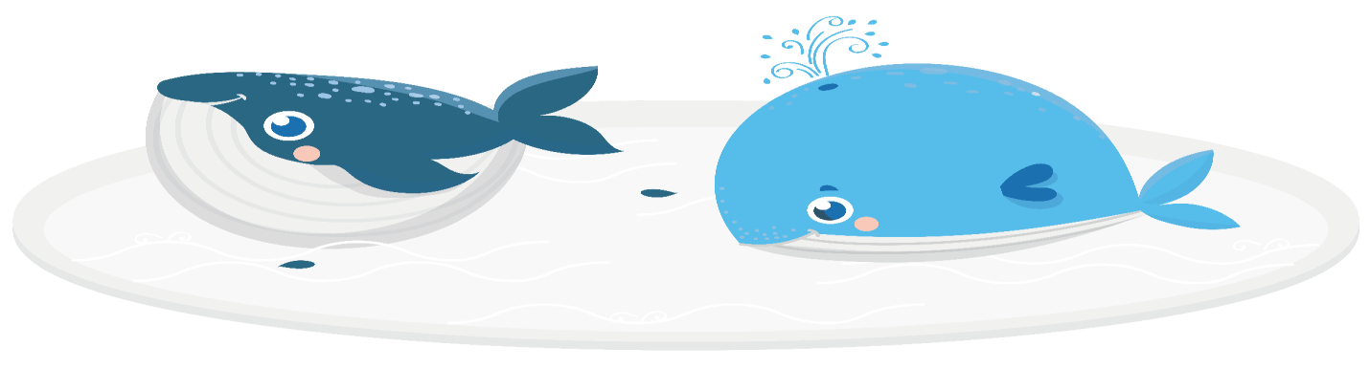

**- What font styles will you use within the website?**

 To make the content easy to read, the website will use a “serif font style” for paragraphs,

lists and other body content, while providing contrast by using a sans serif font style for headings.

**- What features will be displayed on the webpages?**

 We recognize the growth in Smartphone and tablet usage and wants a single website that provides an optimal viewing experience regardless of whether visitors are using a desktop, laptop, tablet, or smartphone. We use a lot of pictures and videos, and the elderly and children can easily browse the web.

Web page contain:-

* HTML5 semantic elements- meta tags, links, images, block and inline content, forms with basic validation, tables, headings, paragraphs , lists
* Fluid layout, media queries, flexible images
* It contain forms.
* Text and font styling
* Styling done using javascript.

**Section 3 – Structure Requirements**

This project is intended to apply HTML5 and CCS techniques in a travel agency page. The business purpose is to display content about their services and features.

Basically, the web page has to use clean navigation and run in the most popular web browser. Only desktop screen size was considered for this version.

The pages follow this structure: HOME PAGE

Level 1

Home Page

External Sites

Pages all linked to each other and to main page

Registra-tion

Tours & Vacations

Contact

About Us

Twitter

Instagram

Facebook

Level 2

Top International Tours

Level 3

Choose your plan

**HOME PAGEWIREFRAME**

Page-Link

Company’s logo

Logo

Home | AboutUs| Tours & Vacations| Registration | Contact

Image

Sub-menu

Tours

Register with Us

Images

paragraph

body

Each fraction of the page implemented semantic HTML5 as it described bellow:

MAIN PAGE

Video

Video

footer

Email. | Twitter. | Facebook. | Instagram.

**HOME PAGE : Desktop viewport**

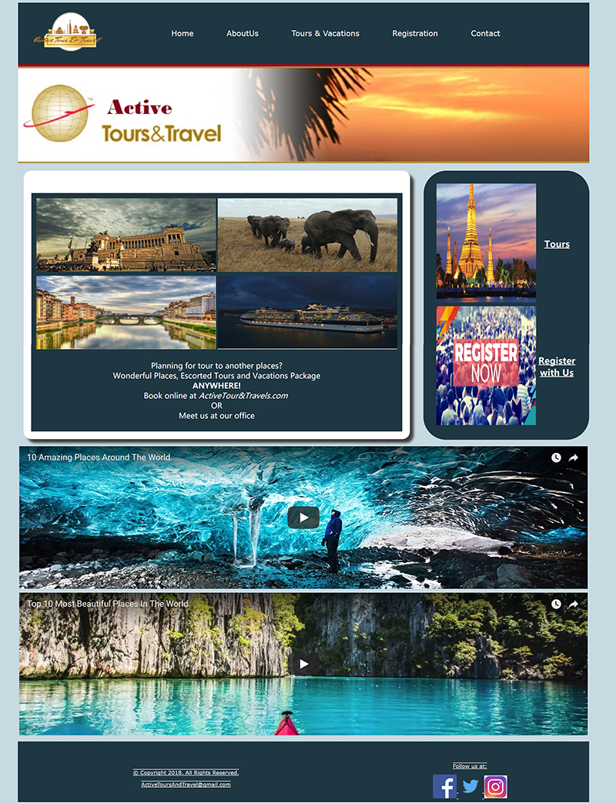

iframe

iframe

Article

Nav | Menu

Header

Aside

Footer

**Home PAGE WIREFRAME IN MOBILE**

Company’s logo

Logo

Home

About Us

Tours & Vacations

Registration

Contact

Page-Link

Image

Images

paragraph

body

Tours

Register with Us

Sub-menu

Video

Email. | Twitter. | Facebook. | Instagram.

Video

footer

**HOME PAGE in mobile viewport**

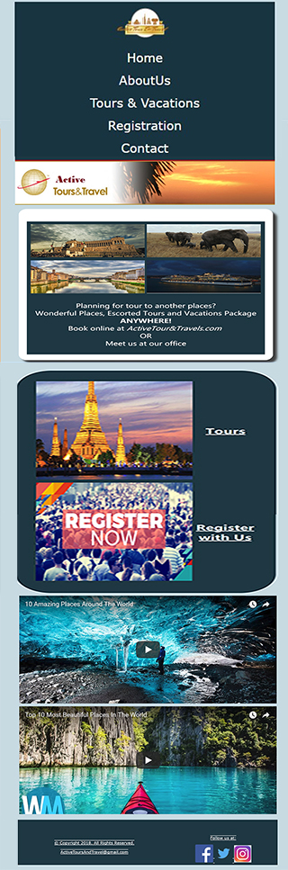

Aside

iframe

Article

Nav | Menu

Header

iframe

Footer

**HOME PAGE WIREFRAME IN TABLET**

Logo

Home | AboutUs| Tours & Vacations|

Registration | Contact

Company’s logo

Image

Page-Link

Images

paragraph

body

Each fraction of the page implemented semantic HTML5 as it described bellow:

Tours

Register with Us

MAIN PAGE

Sub-menu

Video

Video

footer

Email. | Twitter. | Facebook. | Instagram.

**HOME PAGE :Tablet viewport**

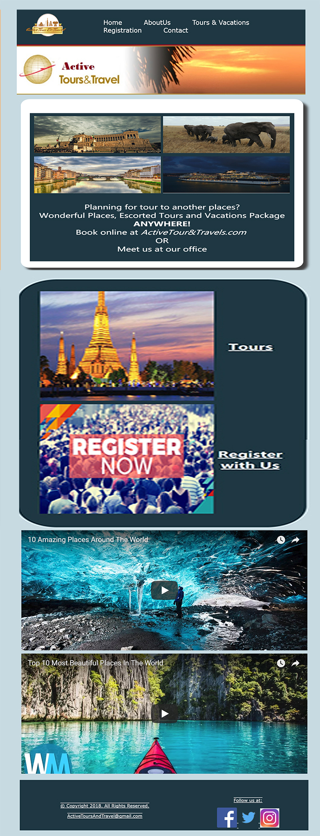

Article

Nav | Menu

Header

iframe

iframe

Aside

Footer

**ABOUT US : WIREFRAME**

Company’s logo

Logo

Home | AboutUs| Tours & Vacations| Registration | Contact

Image

Images

paragraph

body

Each fraction of the page implemented semantic HTML5 as it described bellow:

footer

Email. | Twitter. | Facebook. | Instagram.

MAIN PAGE

**Tours & Vacations: WIREFRAME**

Company’s logo

Logo

Home | AboutUs| Tours & Vacations| Registration | Contact

Image

Sub-menu

Top International Tours List

body

Email. | Twitter. | Facebook. | Instagram.

footer

**REGISTRATION: WIREFRAME**

Company’s logo

Logo

Home | AboutUs| Tours & Vacations| Registration | Contact

Image

Registration

Registrationform

body

Each fraction of the page implemented semantic HTML5 as it described bellow:

footer

Email. | Twitter. | Facebook. | Instagram.

**Contact : WIREFRAME**

Company’s logo

Logo

Home | AboutUs| Tours & Vacations| Registration | Contact

Image

Address

Telephone

E-mail

body

Google map

map

Each fraction of the page implemented semantic HTML5 as it described bellow:

footer

Email. | Twitter. | Facebook. | Instagram.